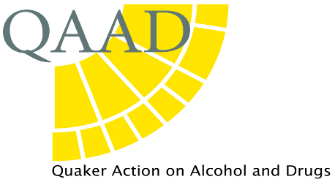
Resources ‘close others’ may find helpful
Talk to Frank is a website that gives information on a wide range of topics and has a ‘Find support near you’ option that gives details of advice and treatment services – both for those using substances and for close others. http://www.talktofrank.com/
ADFAM
This is a website and an agency devoted to help for families and close others. Its website provides very useful information which includes advice, briefings, and the ability to search for support groups for ‘close others’ in their own areas. http://www.adfam.org.uk/home
Rehabilitation units
This is a website that allows you to ‘search’ for different rehabilitation units, though of course funding to take up a place has to be considered separately and arranged through medical or Social Services funding. http://www.rehab-online.org.uk/
QAAD has produced a ‘Resources’ leaflet with some detailed references relating to problems with specific substances or with gambling.
QAAD also maintains a confidential list of Friends who have been personally affected by addiction and are willing to offer some support to others. More information can be obtained from Alison Mather.
Spiritual approaches that Friends have found helpful
Quaker Meetings and Quakers
Friends have also gained insights from other traditions. Some Friends have found the book ‘When Things Fall Apart’ by the Buddhist nun Pema Chodron to be particularly relevant to addiction. Mindfulness can be a particularly helpful in dealing with the extreme anxiety about a loved one who may be at risk.
The London Buddhist Centre and the associated ‘Breathing Space’ group offers mindfulness courses for those experiencing problems with substances http//www.lbc.org.uk/breathingspace.htm
The 12 Step ‘Anonymous’ Groups
Al Anon, Families Anonymous and other associated 12 Step groups offer both support services in the form of helplines and local groups based on the spiritual 12 Step programme of recovery.

Al Anon 020 7403 0888 http://www.al-anonuk.org.uk/
Families Anonymous http://famanon.org.uk/ 0845 1200 660

Ideas/models concepts that people have found helpful
- The Karpman Triangle
The Karpman ‘drama’ triangle has been used in many contexts to describe relationships that can get ‘stuck’ in this pattern. Many have found it helpful in considering addiction - as ‘close others’ may find themselves in the ‘rescuer’ position (as, indeed, can counsellors). 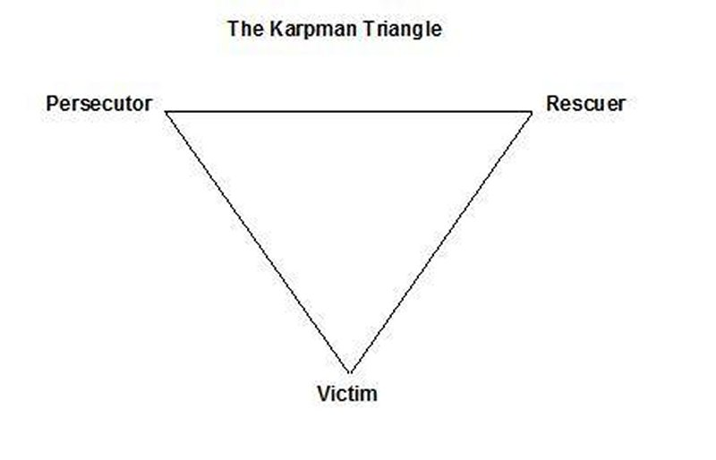
These behaviours could be considered as extensions of roles we all take in many relationships (support into rescue, for example). Indications that we may be moving into this powerful triangle are: a feeling of compulsion about, being driven to, or a general ‘lack of choiceness’ about acting in the role; each person often has a ‘usual’ role, but we move through them all (particularly victim); the triangle becomes a repetitive pattern that gets ‘acted out’ in many situations. A positive feature is that if one person steps out of these roles and maintains a position of not adopting any of them, the pattern cannot continue. Making ‘boundary’ agreements is often seen as one step that may help achieve this.
The Five Step model of support (Capello, Templeton, Orford, Velleman)
This was developed to help services such as advice agencies and medical professionals give improved support ‘close others’. It is based on research which found there were common ways of coping in families from many different cultures and countries. The authors systematised these ways of coping into three main types:
- engaged – which they call ‘standing up to it’ (e.g. confronting);
- tolerate, which they call ‘putting up with it’ (e.g. ignoring or ‘covering’);
- withdrawal - which was characterised by ‘withdrawing and gaining independence

This model stresses the difficulties of the position rather than the ‘pathology’ of the person. The authors say: the model upon which the method is based conceives of family members as ordinary people facing highly stressful circumstances.

They suggest that it is helpful for the close others to identify their current ‘coping’ style, to explore the pros and cons of it, and to look at alternative actions in detail – which can help increase the feeling of choice (and helps escape the Karpman triangle, for example). The aim is to increase advantages and decrease disadvantages – so, for example, to remain supportive without ‘covering’.

Their research also found that although close others can often identify people who might be supportive, they feel a barrier to gaining it. An important part of the 4th and 5th stage of model is broadening out and accessing support. Sources of help for the family member who is ‘using’ are also identified.
Ref: Copello A et al (2010). The 5-step method: Principles and Practice. Drugs: education, prevention and policy; 17 (S1): 86-99.
The Prochaska and di Clemente ‘model of change’
This model systematises the different ‘stages’ that a person may go through during addiction and recovery. Many have found it useful in considering ‘where someone is at’ in order to be able to offer the most appropriate support at that particular time. The table has been adapted from advice given by Adfam and others.
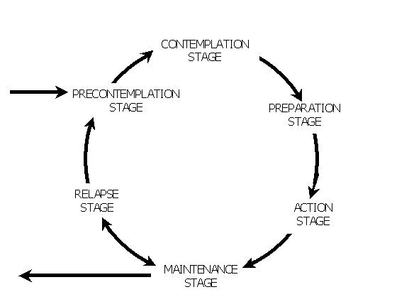
Stage for the ‘user’ for the close other
Pre-contemplation | I don’t think I have a problem | Limit effects for self and others, including by seeking support for yourself. Give honest feedback on consequences of the  behaviour
Contemplation | Maybe I do have a problem | Limit effects on self and others  Give assistance in helping the person explore the options for change
Preparation | I think I will make a change and I’m preparing how to do it. This may well involve others - advice services, treatment, or self-help groups (or simply friends) | Help and encourage the plan and recognise the anxiety this will hold for the person, as well as your own. Consider/adopt what support you need yourself.
Action | I am putting my plan into action | Encourage the positive changes; recognise ‘lapses’ may occur
Maintenance | I’ve made the change! This new behaviour and attitudes continue to be practised (this is hard!) | Support the changes practically, and recognise that shifts in your relationship may need to occur. Recognise that some problems may remain.
Lapse and relapse | This can occur at any point, including maintenance. A brief lapse may be brought under control with a return to maintenance; a full relapse means a return to the behaviour and the need to start again in earlier parts of the cycle | Support the person in returning to the networks and patterns that helped them achieve the change; maintain your own networks of support

