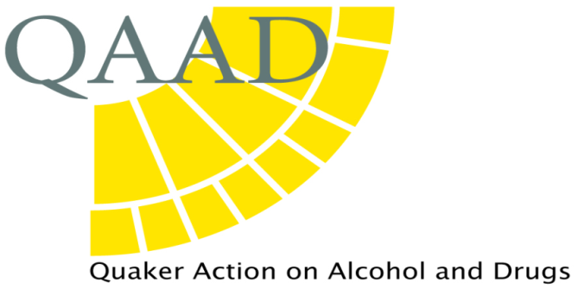
Registered Charity No: 1059310
A Company Limited by Guarantee Registration No 32655669

Director: Alison Mather
Telephone: 0117 9246981
E- mail: alison@qaad.org
Website: www.qaad.org

QAAD response to the Welsh government’s consultation on the future of Minimum Unit Price in Wales, Autumn 2025

Question 1: Do you think minimum unit pricing should continue in Wales? YES

- Evidence provided by the independent evaluators, and research conducted by Alcohol Change UK and other organisations, suggests that the implementation of MUP in Wales has broadly succeeded in meeting the Welsh government’s objective of helping to reduce consumption and related harm. Specifically, it has served to target, and increase, the price of high-strength, cheap alcohol products which have caused such considerable harm for dependent drinkers. However, this is a complex area, and data relating to alcohol-specific deaths, for example, is not clear cut and complicated by the COVID pandemic and its aftermath.
- It is acknowledged that MUP is not a perfect mechanism, nor can it be expected to deliver significant change on its own. We agree that it should be seen as a key component of a wider strategic approach for addressing this serious, complex public health issue i.e. mechanisms for reducing consumption must be combined with improved access to treatment and support, preventative measures, and the provision of clear public health information.
- We share the evaluators’ and others’ concerns about MUP’s impact on dependent drinkers, particularly those from deprived communities, who may have substituted alcohol for food and other essentials. In its response to this consultation, ACUK highlighted that this pre-dates MUP: dependent and harmful drinkers have long been found to be malnourished and underweight. Many also struggle with physical and mental health problems. Addiction takes away choice and it is our strong belief that the solution is not to make cheaper alcohol available by abolishing MUP. Rather, we believe that alcohol-related harm must be addressed in the context of a person’s whole life i.e. complex needs and co-morbid addictions which threaten health, well-being and financial security. We agree with ACUK’s suggestion concerning the expansion of access to food banks and its Feeding Recovery project which provides nourishing food, skills, and a safe social space to reduce isolation. We hope that funding will be made available to expand such innovative approaches in Wales in future.
- For every life lost, or damaged by permanent disability, due to alcohol, there are an estimated 6-10 ‘close others’ who are also seriously affected. We share the concerns about the evaluation’s focus on adults and agree with the recommendation to widen this focus to include children, young people and families.
- It is encouraging to see the sustained trend of falling consumption by young people in recent years. It has been suggested that MUP can be regarded as a preventative measure itself by deterring some young people from heavy drinking due to increased cost, potentially reducing the risk of alcohol problems in adulthood.
- QAAD is particularly concerned about the harm caused to children and young people living with parental and wider familial alcohol problems. This can be significant, and is often underestimated, with limited research conducted in this area. NACO has found that children of alcoholics have diagnosable mental health disorders, show behavioural issues such as aggression, and have poorer academic attainment and cognitive function. In addition, such young people often struggle to access support, a situation which was exacerbated during the COVID pandemic and will undoubtedly still be affecting those young people today.
- The consultation confirms that alcohol is a major cause of death and illness in Wales and that alcohol-related disease levels remain high. It is understandable that the primary focus is on people who are already drinking at harmful or hazardous levels. The World Health Organisation’s view is that there is ‘no safe level’ of consumption and in her introduction to the Westminster Hall debate on alcohol and cancer in July, Cat Smith MP highlighted the prevalence and risks of cancer related to alcohol use, even amongst ‘moderate’ drinkers. Increasing and continuing to evaluate and adjust the MUP level could contribute to improving whole population health outcomes and reduce NHS expenditure. In addition, we suggest that improving public understanding and awareness of MUP’s impact could help to overcome any public resistance to future increases.
- We are aware that if MUP is not renewed before March 2026, it will come to an end and there will be no provision for reinstatement without the permission of the UK government due to the Wales Act 2017. We are therefore pleased that the Welsh government has recommended its continuation.
Question 2: If minimum unit pricing continues, do you agree with a new level being set at 65p per unit? YES

- The independent evaluation and research conducted by ACUK confirms that inflation and the cost of living have eroded the current level of MUP, with the suggestion that 50p now equates to 37p in 2020 and even the recommended 65p equates to 50p in 2020.
- The consultation states that 94.4% of alcohol sold in Wales is already priced at 60p MUP or more and heavy drinkers buying 93% at this level.
- In our 2018 response to the Welsh government’s consultation on the introduction MUP, we suggested that the initial level be set at 60p or higher. We understood the Welsh government’s decision to mirror Scotland’s initial 50p MUP, and agree with the current recommendation to follow Scotland’s lead in raising it to 65p in 2026.
- We hope that the Welsh government may be willing to consider future increases, if longitudinal evidence establishes clear and cumulative reductions in alcohol-related harm. For this reason, we support the recommendation to regularly review and adjust MUP to ensure that its impact is maintained. Strengthening the evaluation process, as recommended, will ensure that future decisions are evidence-led.
- We note the government’s stated objective to balance harm reduction with the potential impact of increasing MUP on whole population consumption and the retail market. We understand that consideration needs to be given to the potential loss of £109m in treasury revenue over 20 years if MUP is raised to 65p. However, the projections also predict a saving of £14.9m for the NHS over the same period, and there are wider potential cost benefits related to public services, benefits, employment, criminal justice and education. The cost of just one lost life is inestimable.
- We support SHAAP’s call for a levy on alcohol retailers, based on the ‘polluter pays’ principle, which could be used to increase provision of substance use treatment and support.

